Set timespan to 25 years
- Incubation period - time between exposure to pathogen
  - 10-14 days after the exposure to measles
- Infectious period - symptoms
  - contagious from 4 days before the onset of the rash to 4 days after the rash appears
  - virus spreads through respiratory droplets when an infected person coughs, sneezes, or talks
    - can linger in the air for up to 2 hours (after infected person has left the area)
  - Symptoms include high fever, cough, runny nose, conjunctivitis, and even rash
- The baseline reproductive number (R₀) for measles is generally estimated to be about 12–18.
  - 1 person with measles can infect 12–18 other people in a population where no one is immune (no vaccination or prior infection).
- Measles spreads through exponential growth
  - 1 infected person infects ~12 people
  - 12 people infect 144 people
  - 144 people infect 1728 people, and so on
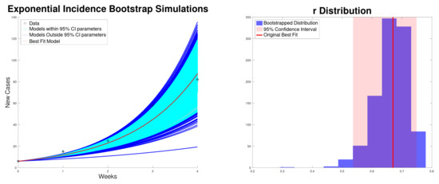
Source: Modeling and Characterizing the Growth of the Texas–New Mexico Measles Outbreak of 2025

